  L1 Su23

Q1:

Software Requirements Specification

for

FU Library Management System website

**Version 1.0 approved**

**Prepared by**

**Trần Xuân Tiến, SE161471**

**FPT University Campus Ho Chi Minh**

**Monday, July - 24 - 2023**

Q2:

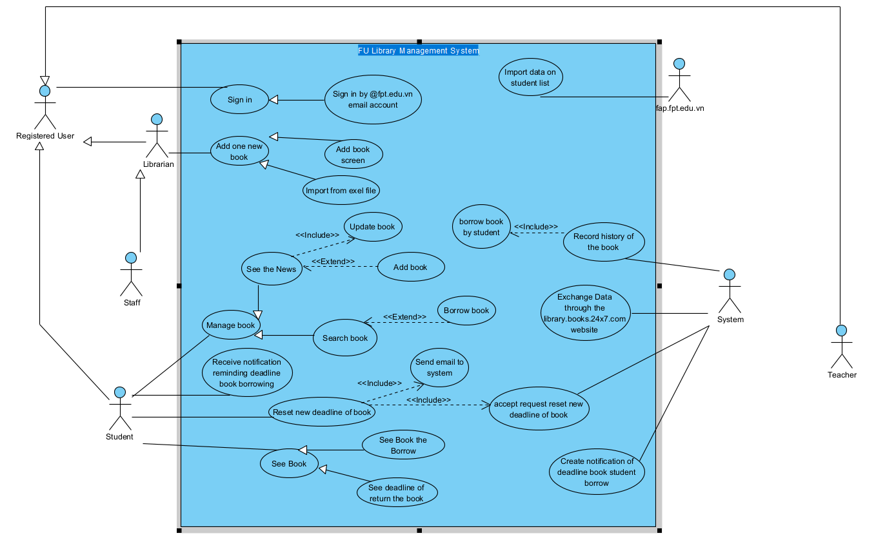

1. In this exam paper, the name of the rectangle is: FU Library Management System website
2. The actor may be human, other software systems or devices. In this exam paper, list the name of >= 4 actors is:  
   - Staff  
   - Student  
   - Teacher  
   - System
3. In this exam paper, list the name of >= 5 use cases are:  
   - Manage book  
   - Add book  
   - Update book  
   - Add one new book  
   - Reset new deadline of book
4. The actors are inside or outside of the rectangle: Outside
5. The ovals represent the use cases are inside or outside of the rectangle: Inside
6. The primary actor of the use case add book is: Librarian
7. The secondary actor of the use case add book: Administrator or Student or N/A

8.Based on the fact you already used http://ds/libol.fpt.edu.vn. The use cases in this exam paper may have relationship.

8.a List the name of two use cases that have extend relationship: See the News, Add book

8.b The name of base use case (in 8.a) is: See the News

8.c The name of extends use case (in 8.a) is: Add book

8.d The dashed line with an arrow that points to which use case: See the News

9. Based on the fact you already used http://ds/libol.fpt.edu.vn, the use cases in this exam paper may have relationship.

9.a List the name of two use cases that have include relationship: See the New, Update book

9.b The name of based use case (in 9.a) is: See the New

9.c The name of include use case (in 9s.a) is: Update book

9.d The dashed line with an arrow that points to which use case? Update book

Q3:

| **ID and Name:** | **UC-1, Add new book** | | |
| --- | --- | --- | --- |
| Created By | Trần Xuân Tiến | Date Created: | 24/07/2023 |
| Primary Actor | Librarian | Secondary Actors | N/A |
| Priority | Medium | Frequency of | Usually |
|  |  | Use |  |
|  |  |  |  |
|  |  |  |  |
|  |  |  |  |
|  |  |  |  |
|  |  |  |  |
| Trigger | The librarian wants to add a new book to the system | | |

| Step | Actor Action |
| --- | --- |
| 1 | The librarian selects the "Add Book" option from the book list menu. |
| 2 | The system displays the "Add New Book" form. |

| Description | This use case allows librarian to add a new book to the system |
| --- | --- |
| Preconditions | The librarian has logged in to the system.  The librarian has the necessary privileges to add book to the book list.  The book list already exists in the system. |
| Post-conditions | Success:   * The new book is added to the book list. * The book list is updated with the new book. * The librarian can view the newly added book in the book list.   Fail: The system shows error message corresponding to error code |
| Normal Flow |  |

| 3 | The librarian enters the book statement, and information of book. |
| --- | --- |
| 4 | The librarian submits the form. |
| 5 | The system validates the form and adds the new book to the book list. |

|  |  |
| --- | --- |
| Alternative Flow | * If the librarian enters an invalid or incomplete form, the system displays an error message and prompts the librarian to correct the form. * If the teacher cancels the form submission, the system redirects to the book list menu. * If the librarian decides not to add a new book, the system redirects to the book list menu. |
| Exceptions: | If the system encounters an error while adding a new question, it displays an error message and prompts the librarian to try again.  If the librarian does not have the necessary privileges to add book to the book list, the system displays an error message. |
| Business Rules: | The book statement should not exceed 500 characters. Each book must have at least two three information. |

| Assumptions | The system has the necessary database to store the book list.  The librarian has the required knowledge to formulate book and use system. |
| --- | --- |

**Q4:   
Two non-functional requirement:**

1. The website must be able to handle at least 500 concurrent users without noticeably slowing down:

We may test this by simulating 500 users at once and monitoring the response time. The test can be deemed successful if the reaction time stays within a reasonable range.

2. The website must have documentation, such as user manuals and technical specifications, to help usable easily:

This can be tested by showing 100 users the site's documentation. The test can be considered passed if it is ensured that more than 70 people can and thoroughly understand and grasp how to use the website easily.